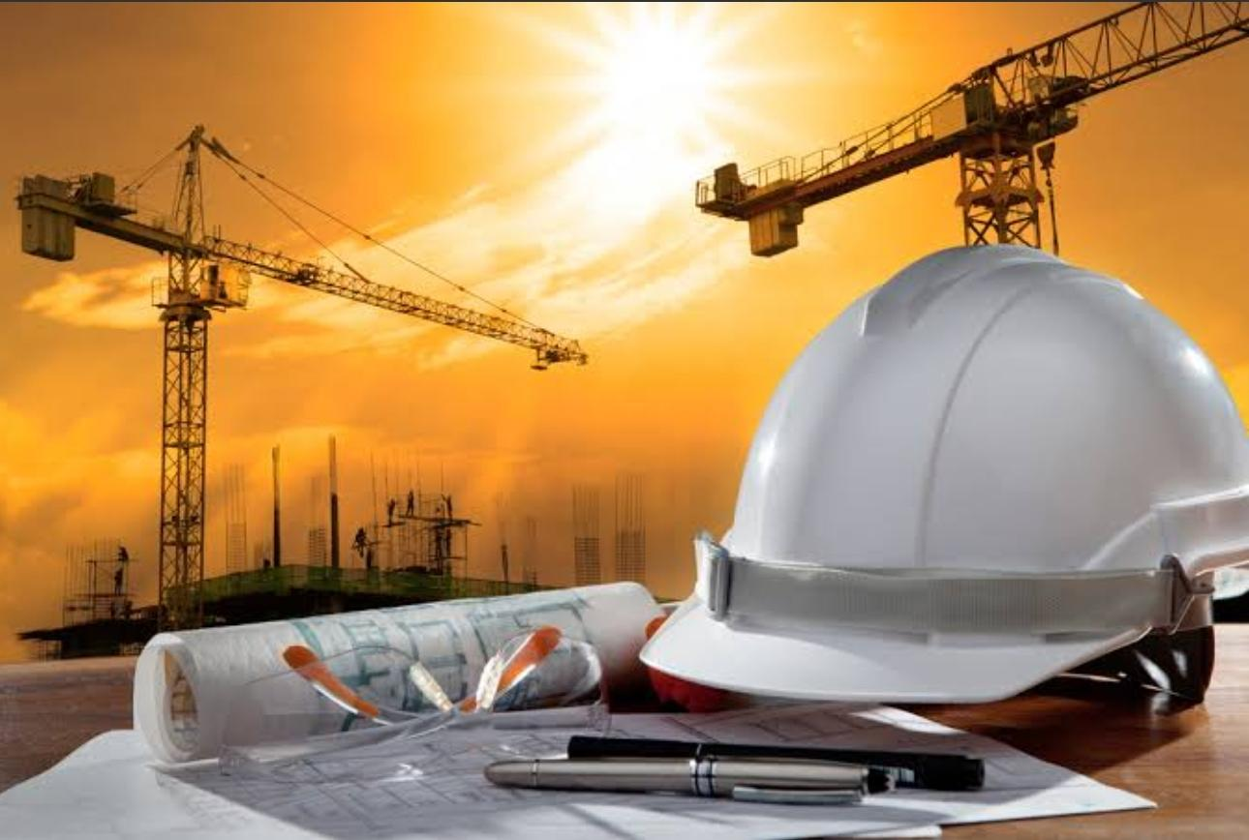

BASICS OF CIVIL ENGINEERING

**MODULE 2**

SUSAN ANN ROY



Contents

* **Surveying**: Importance, objectives and principles.
* **Construction materials,** **Conventional construction materials:** types, properties and uses of building materials: bricks, stones, cement, sand and timber
* **Cement concrete:**  - Constituent materials, properties and types.
* **Steel:**- Steel sections and steel reinforcements, types and uses.
* **Modern construction materials:**- Architectural glass, ceramics, Plastics, composite materials, thermal and acoustic insulating materials, decorative panels, waterproofing materials. Modern uses of gypsum, prefabricated building components (brief discussion only).

SURVEYING

[](https://www.needpix.com/photo/1861618/surveying-geodesy-equipment-instrument-land-surveyor)

# Introduction

* Surveying is the art of determining the relative positions of points on, above or beneath the surface of the earth by means of direct or indirect measurements of distance, direction and elevation.
* It also includes the art of establishing points by predetermined angular and linear measurements.
* The application of surveying requires skill as well as the knowledge of mathematics, physics, and to some extent, astronomy.

# Importance

The knowledge of surveying is advantageous in many phases of Civil engineering. Surveying is of vital importance in any Civil engineering project. Some of the basic importance of Surveying is discussed below.

* Surveying is carried out to prepare a plan and a section of an area to be covered by the project. From these prepared maps and sections the best possible alignment, amount of earthwork and other necessary details depending upon the nature of the project can be calculated.
* The planning and design of all Civil Engineering projects such as railways, highways, tunneling, irrigation, dams, reservoirs, waterworks, sewerage works, airfields, ports, massive buildings, etc. are based upon surveying measurements.
* During execution, the project of any magnitude is constructed along the lines and points established by surveying. The measurement of land and the fixation of its boundaries cannot be done without surveying.
* The economic feasibility and engineering feasibility of a project cannot be properly ascertained without undertaking a survey work.
* The execution of hydrographic and oceanographic charting and mapping requires surveying. Surveying is used to prepare the topographic map of a land surface of the earth.

# Objectives

* To prepare necessary maps (geological, archaeological, military) of an area.
* To locate arbitrary points, direction and length of lines, boundary lines, etc
* To set out the lines and grades needed for the construction of buildings, roads, dams, and other structures
* To calculate areas, volumes and other related quantities Measurement of distances between two points
* Determination of relative position of points

# Principles

### 1. Working from whole to part:

* To do this, the area to be surveyed is divided into smaller triangles and the area will be surveyed from the boundary to the innermost triangle.
* The purpose of working from whole to part is to localize the errors and to control the accumulation of errors which, otherwise, would expand to greater magnitudes if the reverse process is followed, thus making the work uncontrollable at the end.

### 2. Location of a point by measurement from at least two points of reference.

The relative positions of the points to be surveyed should be located by measurement from at least two points of reference, the positions of which have already been fixed or Fix the position of any point from at least two permanent objects or stations.

* Eg. Two control points are selected in the area and the distance between them is measured and plotted on a paper.
* All other points to be surveyed are based on these two points. If A and B are two control points and C is the point to be measured, the methods are Measure distance AC and BC.
* The meeting points of two distances give the position of point C. A perpendicular CD is dropped to the reference line AB. Distance AD and DC is measured and thus C is plotted.
* Distance BC and angle ABC is measured to plot point C. Angle BAC and angle ABC measured and point C is determined.
* Distance AC and angle ABC is measured and point C is determined.

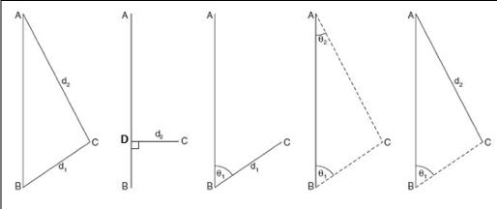

CONSTRUCTION MATERIALS

# BRICKS

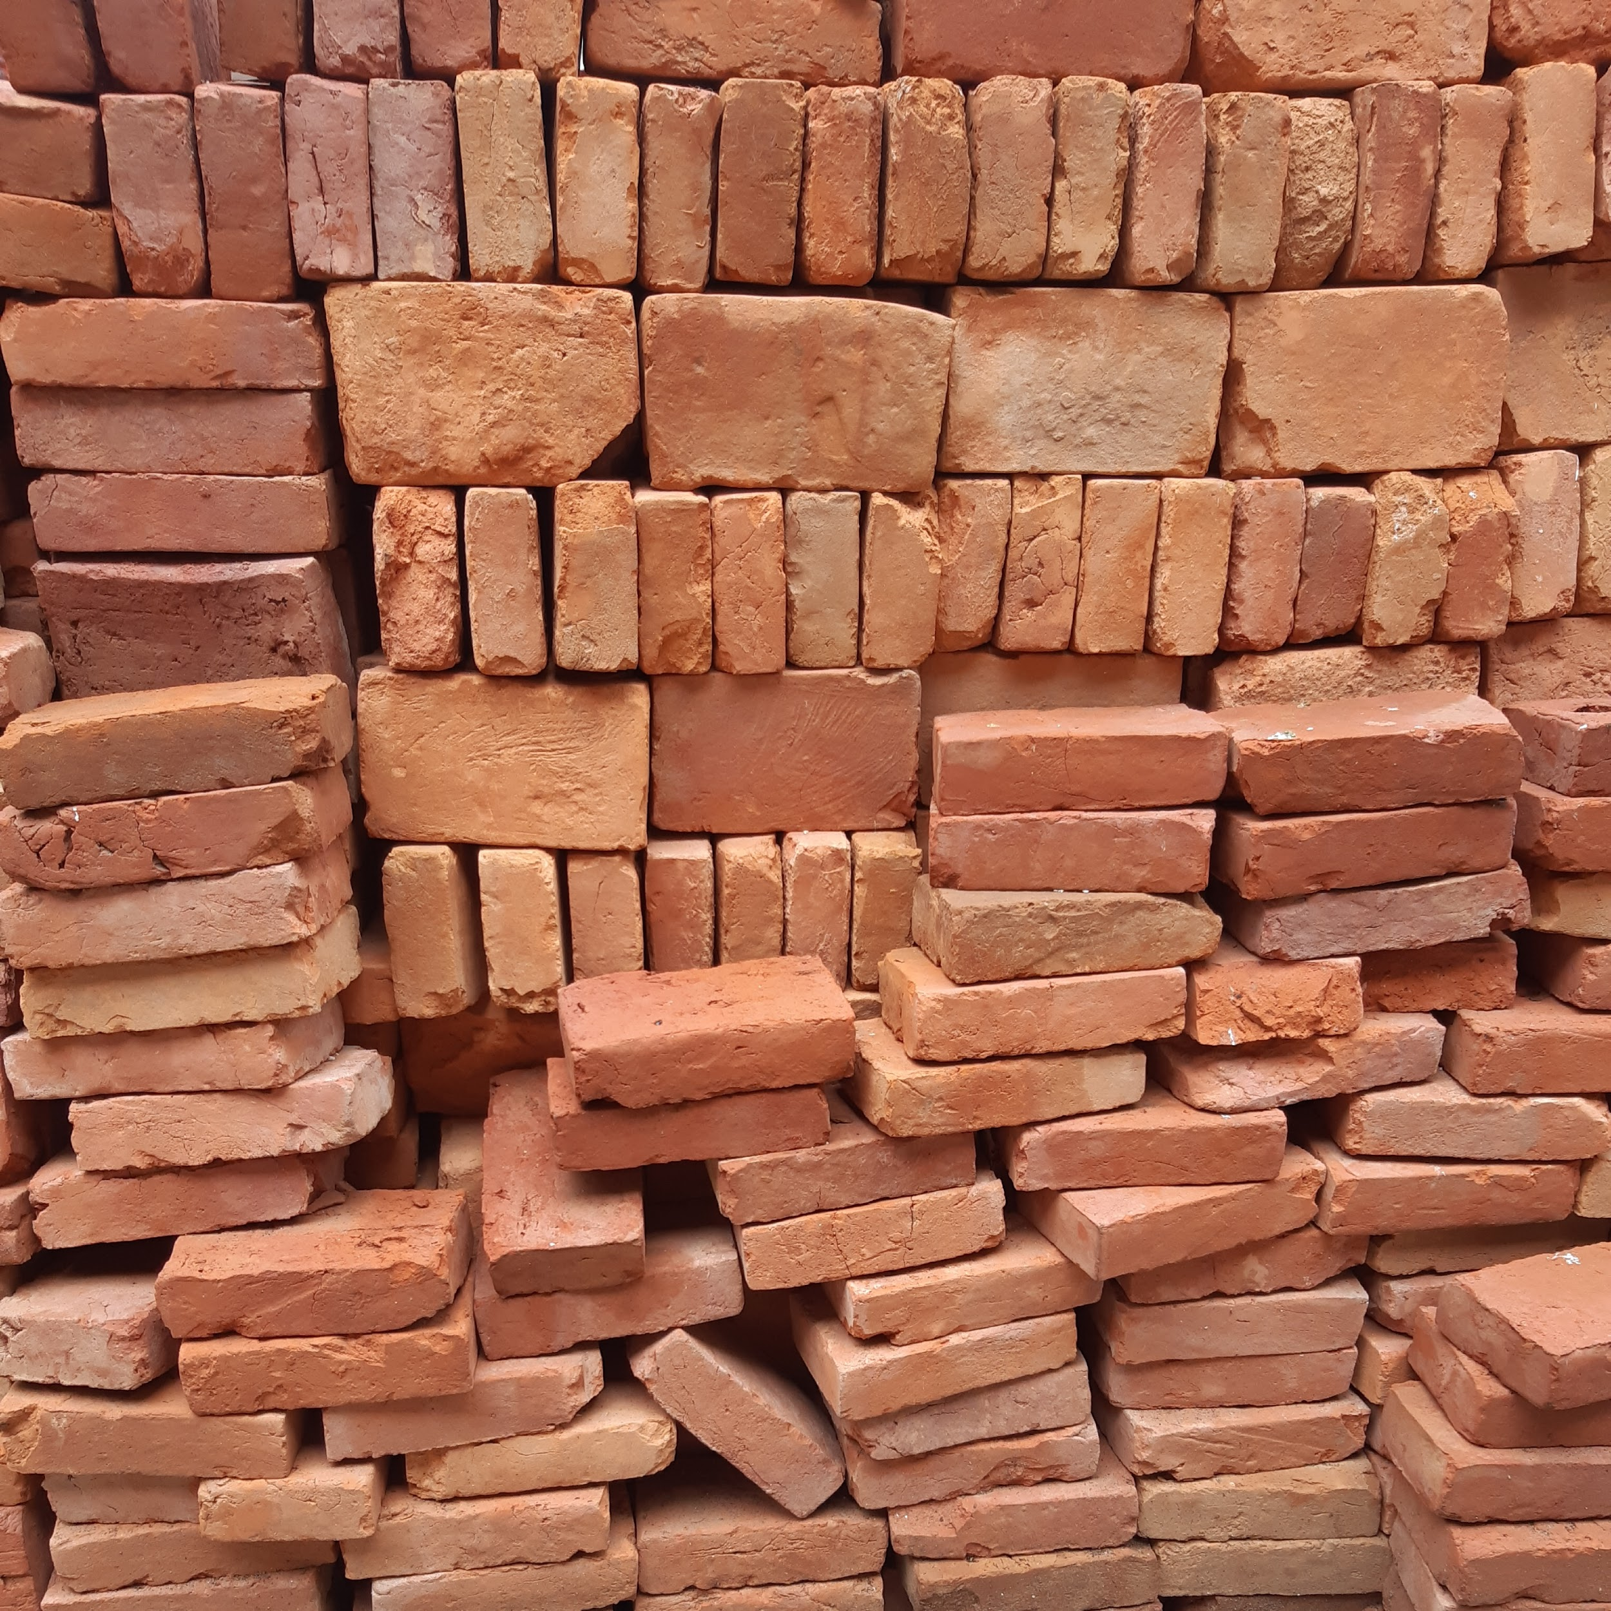

# 

# 

* Brick is one of the oldest building materials made of burnt clay.
* Bricks are obtained by molding clay in rectangular blocks of uniform size and then by drying and burning them in kilns.
* Advantages: Light in weight, Simple to handle. Durability Strength Low cost Easily available.
* Specification of Size of bricks: BIS recommended size-
* Modular bricks (Standard size) (19 cm x 9 cm x 9 cm).
* Nominal size of brick includes the mortar thickness (20 cm X 10 cm X 10 cm).
* Bricks which are not standardized – traditional bricks.
* Average weight of brick 3-3.5 kg.

### Classification

#### 1. Unburned bricks: -

These bricks are sun dried. They have low strength and are used in temporary and cheap structures.

#### 2. Burnt bricks: -

These bricks are used in all construction works.

##### **a) First class bricks:-**

* It should have all the requirements of a good standard brick.
* Made of regular good earth, thoroughly burnt and have regular shape, uniform reddish color, and sharp edges.
* They should not absorb more than 20% of its dry weight, when immersed in water for 24 hours.
* The thickness of mortar joints does not exceed 10 mm.
* Its compressive strength should be greater than 100 kg/ cm2.
* They are table molded and burnt in kilns. It is used for quality work.

##### **b) Second class bricks:-**

* These bricks are molded on ground and are burnt in kilns.
* Surface of the brick is rough and the shape is irregular.
* Water absorption should not be more than 22% of its weight.
* Thickness of mortar joints is 12 mm.
* Minimum compressive strength 80 kg/ cm2.
* Used at places where the brickwork is to be provided with a coat of plaster and for internal walls.

##### **c) Third class bricks:-**

* They are not hard.
* Rough surfaces with irregular edges.
* Half burnt bricks of uniform reddish color.
* Defects in color, shape and size.
* Water absorption is not more than 25%.
* Minimum compressive strength 45 kg/ cm2
* These bricks give a dull sound when struck together.
* Used for unimportant and temporary structures and at places where the rainfall is not heavy.

##### **d) Fourth class bricks:-**

* Over burnt, irregular shape, dark color.
* Used as aggregate for concrete.

### Properties of good bricks and tests on bricks

* **Shape and size:** The bricks should conform to the IS Specification (Indian standard specification) with respect to shape, size, strength and water absorption.
* **Presence of soluble salts**: The presence of soluble salts in bricks will cause efflorescence on the surface of bricks. Immerse the brick in water for 24 hours and dry it in shade. Presence of gray or white deposit on the surface indicates the presence of soluble salts. Rating of efflorescence shall not be more than 'moderate' up to class 12·5 and 'slight' for higher classes
* **Color:** Color should be uniform ( uniform deep red)
* **Fire resistance**: It should have low thermal conductivity and adequate fire resistance. Ordinary brick can resist temperature upto 12000C
* **Structure**: It should have a homogeneous and uniform fine compact structure free from voids and lumps when broken.
* • **Water Absorption:** After immersion in cold water for 24 hours: • water absorption shall not be more than 20 % by weight up to class 12.5 and • 15 % by weight for higher classes.
* **Soundness test**: It should emit a clear metallic ringing sound when struck with each other.
* It should not break, if the brick is dropped from a height of 1 m. It should be sufficiently hard.
* **Hardness Test:** No impression should be made when scratched with nails.
* It should have perfect right angle edges, well burnt in kilns, copper coloured, free from cracks with sharp and square edges.
* **Crushing strength:** The crushing strength of a brick should not be less than 3.5N/mm2
* . A good brick should be durable and able to resist the effects of weathering agencies like temperature, rain, etc.

### Uses

* Constructing walls, arches, buildings, cornices, roads, pavements, etc
* Lining sewer lines
* Fire resistant bricks for lining ovens, furnaces, chimneys
* Making khoa / broken bricks of required size as aggregates in concrete
* Manufacture of surki / powdered bricks for lime plaster and lime concrete
* Perforated and hollow bricks for providing insulation

# STONES

# 

# 

# 

# 

* A Building Stone is a piece of rock quarried and worked into a specific size and shape for a particular purpose.
* The properties of stones depend upon the mother rock from which they are extracted.
* Stones quarried fresh from the rock are irregular in shape and size and are soft.
* They are cut into desired shape & size and seasoned before put to use in construction. Stones are long lasting and naturally available in large quantities.

### Qualities of good stone

* **Appearance:** Good building stone should be of uniform color, and free from clay holes, spots of other color bands etc capable of preserving the color for longtime.
* **Seasoning**: Stones fresh from quarry contain moisture (Quarry sap), making the stone soft and hence easy to work. Desirable for dressing, carving etc. Stones should be dried or seasoned for 6 to 12 months, before using in structural work
* **Crushing Strength**: A good building stone should have sufficient crushing strength to withstand the load of superstructure .In general; it should not be less than 1000 kg /cm2
* **Hardness, Toughness and resistance to Abrasion:** The stone to be used in stairs, pavements, as railway ballast or road metal must be sufficiently hard, tough and resistant to abrasion, it must be able to resist wear and tear. (Coefficient of hardness >14. Toughness index > 13).
* **Durability:** A good building stone must be durable enough to resist the effect of weathering agencies like rain, wind, temperature etc. It should have fine grained, compact and crystalline structure.
* **Texture:** A good building stone should have a close grained and compact texture.
* **Seasoning**: Stones should be well seasoned before putting into use. A period of about 6 to 12 months is considered to be sufficient for proper seasoning. Seasoning is best done by keeping the stones in open sheds for about 6 to 12months.
* **Workability**: The stone to be used for ornamental carving and architectural appearance should be easily and economically dressed.
* **Porosity:** A good building stone should be less porous. It should not absorb more than 5% water by weight after 24 hours. Any stone absorbing 10% of water should be rejected.
* **Resistance to fire**: A good building stone should be fireproof. Sandstone, Argillaceous stone resists fire quite well.
* **Specific gravity**: it is a measure of weight of the stone. The stone to be used on heavy engineering works, docks, harbors, gravity dams etc. must have high specific gravity. It varies from 2.4 to 2.8

### Types of stones

| IGNEOUS | SEDIMENTARY | METAMORPHIC |
| --- | --- | --- |
| STRATIFIED | UNSTRATIFIED | FOLIATED |
| SILICEOUS | ARGILLACEOUS | CALCAREOUS |

#### **1.Geological Classification •**

##### **Igneous rocks** - Rocks formed by cooling and solidifying of Magma (Granite, Dolerite, Basalt)

##### **Sedimentary rocks** - Rocks formed by the deposition of products of weathering on pre-existing rocks (Eg: Gravel, Sandstone, Limestone, Gypsum, Lignite etc.)

##### **Metamorphic rocks** - Rocks created by the physical or chemical alteration by heat and pressure of an existing igneous or sedimentary material into a denser form. Eg: Granite becomes gneiss, Mudstone become slate, Limestone changes to Marble

#### 2.**Physical Classification Based on general structure of rock**

##### **Stratified Rocks**

- have layered structure (planes of stratification) and can split along these planes. Sedimentary rocks are distinctly stratified rocks

##### **UnStratified Rocks**

- do not possess planes of stratification, structure may be crystalline granular or compact granular. Igneous rocks of volcanic agency and sedimentary rocks affected by movements of earth are of this type.

##### **Foliated Rocks**

- have a tendency to split along a definite direction. Common in metamorphic rocks

#### **3.Chemical classification**

##### **Siliceous rocks -** Main constituent is silica -hard and durable Eg: Granite, quartzite

##### **Argillaceous rocks -**Main constituent is argil (clay) -Hard and durable, but brittle, cannot withstand shock Eg: Slate and Laterite

##### **Calcareous rocks** -Main constituent is calcium carbonate Eg: Limestone and Marble

### Uses of stones

1. Structure Stones are used for foundations, walls, columns, lintels, arches, roofs, floors, damp proof course etc.

2. Face works Stones are adopted to give a massive appearance to the structure. Facing Walls of bricks is done in stones of desired shades. This is known as composite masonry.

3. Stones are used to cover the floors of buildings of all types. They are also adopted to form paving of roads, foot paths etc

. 4. Basic material Stones are disintegrated and converted to form a basic material for cement concrete, moorum of roads, calcareous cements, artificial stones, hollow blocks etc.

5. Miscellaneous Stones are also used for (i) ballast for railways (ii) flux in blast furnace (iii) Blocks in the construction of bridges, piers, abutments, retaining walls, lighthouses, dams etc.

|  |  |  |
| --- | --- | --- |
|  |  |  |
|  |  |  |
|  |  |  |

# CEMENT

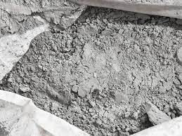

* It is a construction material which possesses very good adhesive and cohesive properties making it good for bonding mineral fragments into a strong compact mass.
* It is a finely ground powder, when mixed with water produces a very hard and strong binding medium. It provides an exothermic reaction.
* Cement is obtained by burning a mixture of calcareous (CaCo3) and argillaceous materials (clay) in 4:1 proportion at a very high temperature.
* Portland cement is commonly used. On setting, cement resembles a type of sandstone found in Portland of England and is known as ordinary Portland cement.

### Good qualities of cement

#### **PHYSICAL**

* Color: Uniform gray color with light greenish shade, free from lumps and should be cool when felt with hand.
* Fineness: Fineness is the measure of mean size of grains in cement. When sieved through 90 µ sieve, the quantity of residue left after sieving should not exceed 10%.
* Setting time: Setting is the process of hardening of the cement paste into a hard solid mass. The initial setting time should not be less than 30min and the final setting time should not be more than 600min.
* Soundness: Cement paste after setting should not undergo large change in volume which may lead to disintegration and cracking. This property is known as soundness. This expansion should be less than 10 mm.

#### 

#### 

#### **CHEMICAL**

1. Ratio of percentage of alumina to iron oxides should not be < 0.66

2. Ratio of percentage of lime to that of Alumina, iron oxides and silica should not be < 0.66 and should not be > 1.02

3. Total loss on ignition should not be > 5%

4. Sulfur content should not be > 2.5%

5. Weight of insoluble residues in cement should not be > 4%.

### Types of cement

**1) Portland Cement:**

Cement obtained by burning and crushing of argillaceous and calcareous materials, which on setting resembles a variety of sandstone found in Portland of England; such cement is known as ordinary Portland cement.

**2) Quick Setting Cement:**

It is produced by adding a small percentage of aluminum sulfate and reduces the percentage of gypsum. The setting time of this type of cement occurs within 30min. It is usually used for laying concrete under water.

**3) Low Heat Cement:**

Low Heat Cement is a specially made cement which generates low heat of hydration during setting. It is produced by the addition of a lower percentage of tricalcium aluminate and higher percentage of dicalcium silicate. It is mainly used for concreting dams, abutments etc.

**4) High Alumina Cement:**

It is produced by the addition of a high percentage of bauxite and lime. The total alumina content in this type of cement should not be less than 32%. In this cement, the initial setting is > 3.5 hrs and final setting time is 5hrs. It can resist frosts, acids and can withstand high temperatures. It attains the maximum strength within a short period. It is mainly used for making refractory concrete, furnace insulation etc.

**5) Expanding Cement:**

It is produced by adding an expanding medium (sulphoaluminate) and a stabilizing agent. It is mainly used for repairing damaged concrete surfaces due to cracks, constructing water retaining structures etc.

**(6) Rapid Hardening Cement:**

It is produced by burning the ingredients at high temperature and with high lime content. It attains high strength within a few days (same initial and final setting time as that of OPC). It is used for those works which are to be completed speedily and economically.

**(7) Sulfate Resisting Cement:**

In this type of cement, the percentage of tricalcium aluminate is <5%. It has high sulphate resisting power. It is used for structures which may be damaged due to severe alkaline conditions.

**(8) White Cement:**

It is prepared from raw materials free from any coloring agents such as oxides of iron, manganese and chromium. It is used for floor finish, plastic work, ornamental work etc.

**(9) Coloured Cement:**

It is produced by mixing mineral pigments (coloring agents) with ordinary cement. It is used for finishing floors, external walls, stairs, trails etc.

**(10) Water Proof Cement:**

It is produced by adding water proof substances like calcium stearate, aluminum stearate and gypsum treated with tannic acid to OPC. It is mainly used for plastering water retaining structures, roofs etc.

### 

|  | QUICK SETTING |  |
| --- | --- | --- |
|  | EXPANDING |  |
|  | WHITE | COLOURED |
| WATERPROOF |  |  |

### 

### Uses of cement

* Cement mortar for Masonry work, plaster and pointing etc.
* Concrete for laying floors, roofs and constructing lintels, beams, weather-shed, stairs, pillars etc.
* Construction for important engineering structures such as bridges, culverts, dams, tunnels, lighthouses, clocks, etc.
* Construction of water, wells, tennis courts, septic tanks, lamp posts, telephone cabins etc. o Making joints for joints, pipes, etc.
* Manufacturing of precast pipes, garden seats, flower pots, etc.
* Preparation of foundation, water tight floors, footpaths, etc.

|  |  |  |
| --- | --- | --- |
|  |  |  |
|  |  |  |

# SAND

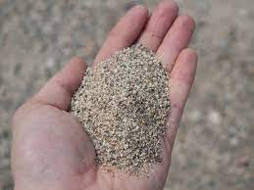

* Sand is a mixture of small grains of rock and granular materials which is mainly defined by size, being finer than gravel and coarser than silt.
* Sand is formed by the weathering of rocks.
* Sand is a non-renewable resource over human timescales, and sand suitable for making concrete is in high demand.

### Classification of sand

1. **Pit Sand:**

* This sand is obtained by forming pits in soils. It is excavated from a depth of about 1-2 m from the ground level.
* This sand is found as deposits in soil and it consists of sharp angular grains, which are free from salts.
* It serves as an excellent material for mortar or concrete work.
* Pit sand must be made free from clay and other organic materials before it can be used in mortar.
* A coating of oxide of iron over the sand grains should be removed.

2. **River sand**

* This sand is widely used for all purposes.
* It is obtained from the banks or beds of rivers and it consists of fine rounded grains.
* The presence of fine rounded grains is due to mutual attrition under the action of water current.
* The river sand is available in clean conditions.
* The river sand is almost white in color.
* It is mainly used for plastering. In north India, Yamuna banks are a great source of River sand

3. **Sea Sand**

* This is obtained from sea shores.
* It is brown in color and it also has fine rounded grain.
* As it is obtained from the sea it contains salt, which is used in attracting moisture from the atmosphere.
* Such absorption causes dampness and disintegration of work.
* It is generally not used for engineering purpose due to its retards setting action of cement.
* It is normally used for non structural purposes

.4**. Artificial Sand**

* This sand is manufactured by crushing either granite or basalt rock using a 3 stage crushing process.
* This is known as robo-sand.
* This is not widely used due to high cost but nowadays it is used in cities for construction purposes.

5**. Volcanic Sand**

* Volcanically affected regions have their own type of dark-colored sand with a different type of characteristics.
* And sometimes coal is found in that.

| PIT SAND | RIVER SAND | SEA SAND |
| --- | --- | --- |
| ARTIFICIAL SAND | VOLCANIC SAND |  |

### Qualities of good sand

* The grains should be sharp, angular and coarse.
* The sand should be free from clay material and organic matters.
* The grains should be of durable minerals. o It should be free from salts.
* The gradation of grain size should be such that it will give minimum voids.
* It should be clean and free from coatings of clay and silt.
* It should not contain organic matter.
* It should be chemically. o Sand is loose particles of hard broken rock, it comprises grains from the disintegrated rock.
* **Sieve analysis**: Sand should be such a size that it should pass through I.S. sieve No.-480 [4.75mm]and should retain it on I.S. No-5[0.05mm] as per Indian standards[I.S]

### Uses of sand

* Used in almost every steps of construction including making concrete, plastering, production of bricks and blocks, and as a construction fill
* Sand forms the ground in which the foundation stays transmitting the load of superstructure to underneath
* It is also used for building artificial islands
* Abrasives and making sand paper
* Filter to purify water
* Deposition and hardening of sand give rise to rock and stone formation

# TIMBER

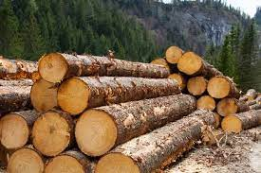

### 

* Timber is one of the oldest materials used in construction.
* It is not only used in construction, but also it caters other needs of human beings.
* The timber thus denotes wood which is suitable for building or carpentry or various other engineering purposes and it is applied to the trees measuring not less than 600 mm in circumference of the trunk.
* The timber was used in the raw form in ancient days, but it is treated, converted, preserved and used now.
* Timber is obtained from trees :

### Types of timber

### 

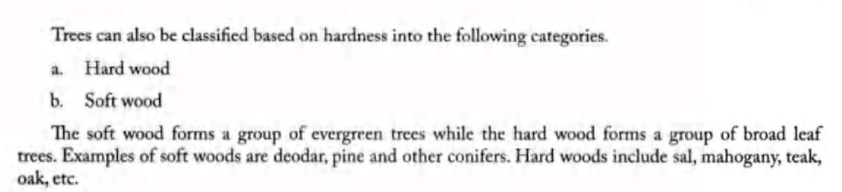

### Characteristics and properties of good timber

* **Strength**: Timber should be strong enough to effectively act as a structural member such as beam, rafter etc.
* **Hardness:** Timber should be hard such that it will be in a position to offer resistance when it is being penetrated by another body.
* **Fire resistant**: Timber is a bad conductor of heat. A good timber should not contain resins & other inflammable oils since they accelerate the action of fire.
* **Structure**: It should possess a uniform structure. Annular rings should be regular & closely located.
* **Elasticity:** Timber should possess this property as such a property is essential when timber is used for bows, carriage shafts, etc.
* **Durability**: Timber should have a long life. It should be capable during its lifespan to resist the action of fungi insects, chemicals, physical & mechanical agencies.
* . **Defects**: It should be free from defects such as shakes, dead knots, flaws or any kind.
* **Weights:** A quality timber should be of heavy weight & uniform along the length under consideration.
* **Fibers**: it should possess straight & close fibers when signifying uniformity in the timber.
* **Workability**: Timber should be easily workable. It should not clog the teeth of the saw.

### Uses of timber

* Wood has been an important construction material since humans began building shelters, houses and boats.
* It is used for all wood construction, including beams, walls, doors, and floors.
* It is used to make solid wood doors
* It is used in both residential and commercial buildings as structural and aesthetic materials.
* It is used in roof construction, in interior doors and their frames, and as exterior cladding.
* Wood is also commonly used as shuttering material to form the mold into which concrete is poured during reinforced concrete construction.
* It is used for construction work such as railway sleepers or the construction of piers.
* wood may be cut into thin sheets which are subsequently glued together to form a light but strong material called plywood, which is much used for internal construction such as doors, built-in furniture and so on.

|  |  |  |
| --- | --- | --- |
|  |  |  |

CEMENT CONCRETE

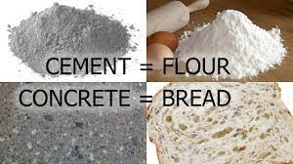

* Concrete is one of the most commonly used building materials.
* Concrete is a composite material made from several readily available constituents (aggregates, sand, cement, water) in specific proportions.(eg: for rcc beams it is 1:2:4 cement -fine aggregate-coarse aggregate and water - cement ratio as separate (0.4-0.6) )
* Concrete is a versatile material that can easily be mixed to meet a variety of special needs and formed to virtually any shape
* Freshly prepared concrete till it has not yet set is called wet or green concrete. After it has thoroughly set and fully hardened it is called set concrete or concrete

### Constituent materials

* **Cement**

- The cement and water form a paste that coats the aggregate and sand in the mix. The paste hardens and binds the aggregates and sand together.

Most of the concrete works are done with ordinary portland cement.

* **Water**

Water is needed to chemically react with the cement (hydration) and too provide workability with the concrete.

* **Fine Aggregate**

The sand obtained from river beds or quarries is used as fine aggregate. The fine aggregate along with the hydrated cement paste fill the space between the coarse aggregate.

* **Coarse Aggregate**

•The coarse aggregate are granular materials obtained from rocks and crushed stones.

They may also be obtained from synthetic material like slag, shale, fly ash and clay for use in light-weight concrete.

* **Admixtures**

Admixtures are additions to the mix used to achieve certain goals.

Some of the admixtures are:

#### **Accelerating admixture-**

accelerators are added to concrete to reduce setting time of the concrete and to accelerate early strength.

#### **Retarding admixtures-**

Are often used in hot weather conditions to delay setting time.

### Properties of cement concrete

* **Durability:** Ability of hardened concrete to resist deterioration caused by weathering, chemicals, and abrasion
* **Workability:** Ease of placing, handling, and finishing Weather Resistance: Resistance to deterioration caused by freezing and thawing, wetting and drying, and heating and cooling
* **Erosion Resistance:** Resistance to deterioration caused by water flow, traffic, and wind blasting
* **Chemical Resistance:** Resistance to deterioration caused by de-icing salts, salt water, sulfate salts
* **Water Tightness:** Resistance to water infiltration
* **Strength:** It should impart good strength to construction
* **Economy:** Since the quality depends mainly on the water to cement ratio, the water requirement should be minimized to reduce the cement requirement (and thus reduce the cost).

### Types of cement concrete

* **PLAIN CEMENT CONCRETE**

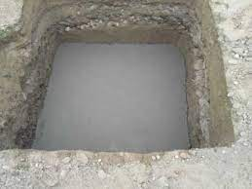

* The cement concrete in which no reinforcement is provided is called plain cement concrete or mass cement concrete.
* This type of concrete is strong in taking compressive stresses but weak in taking tensile stresses.
* USES: Plain cement concrete is commonly used for foundation work and flooring of buildings.
* **REINFORCED CEMENT CONCRETE**

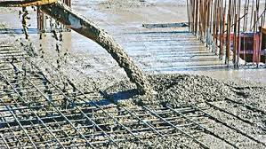

* The cement concrete in which reinforcement is embedded for taking tensile stress is called reinforced cement concrete.
* In this type of concrete the steel reinforcement is to be used generally in the form of round bars,6mm to 32mm dia.
* This concrete along with reinforcement is equally strong in taking tensile, compressive and shear stresses.
* Usual proportions of ingredients in a reinforced concrete are part of cement:1-2parts of sand:2-4parts of crushed stones or gravel.
* USES: RCC is commonly used for construction of slabs, beams, columns, foundation, precast concrete.
* **PRESTRESSED CEMENT CONCRETE**

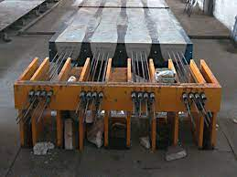

* The cement concrete in which high compressive stresses are artificially induced before their actual use is called prestressed cement concrete.
* Prestressed concrete is a form of concrete used in construction. It is substantially "prestressed" (compressed) during production, in a manner that strengthens it against tensile forces which will exist when in service.
* In this type of cement concrete, the high compressive stresses are induced by pretensioning the reinforcement before placing the concrete, and the reinforcement is released when final setting of the concrete takes place.
* The cured concrete adheres and bonds to the bars and when tension is released it is transferred to the concrete as compression by static friction.
* The essence of prestressed concrete is that once the initial compression has been applied, the resulting material has the characteristics of high-strength concrete when subject to any subsequent compression forces and of ductile high-strength steel when subject to tension forces.
* Tendons may consist of single wires, multi-wire strands or threaded bars that are most commonly made from high-tensile steels or carbon fiber .
* Uses : This concrete can take up high tensile and compressive stresses without development of cracks.
* The quantity of reinforcement can be considerably reduced by using this concrete.

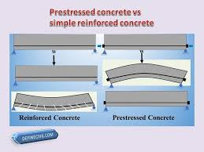

### Uses of cement concrete

* It is used in mortar for plastering, masonry work, pointing, etc.
* It is used for making joints for drains and pipes.
* It is used for water tightness of structure.
* It is used in concrete for laying floors, roofs and constructing lintels, beams, stairs, pillars etc.
* It is used where a hard surface is required for the protection of exposed surfaces of structures against the destructive agents of the weather and certain organic or inorganic chemicals.
* It is used for precast pipes manufacturing, piles, fencing posts etc.
* It is used in the construction of important engineering structures such as bridges, culverts, dams, tunnels, lighthouses etc.
* It is used in the preparation of foundations, watertight floors, footpaths etc.
* It is employed for the construction of wells, water tanks, tennis courts, lamp posts, telephone cabins, roads etc.

STEEL

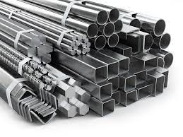

### Steel sections

* **ANGLE SECTIONS**

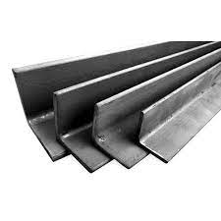 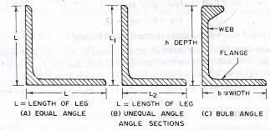

* Angles sections have two legs. If two legs are of equal length then they are known as equal angle section and otherwise unequal angle section.
* Equal angle sections are available in sizes varying from 20mmx 20mm x 3mm to 200mm x 200mm x 25mm and their corresponding weights are 9N/m and 736 N/m.
* Unequal Angle section are available in sizes varying from 30mm x 20mmx 3mm to 200mm x 150mm x 18mm. The corresponding weights are 11N/m and 469 N/m.
* Angle sections are used in the construction of steel roof trusses, filler Joist floors, steel columns, steel beams, cleats and as stiffnersin huge girders.
* **CHANNEL SECTIONS**

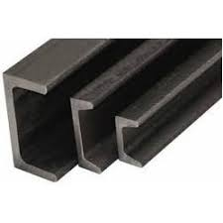

* Channel section consist of a web and two equal flanges
* . Typically a channel section is designated by the height of the web and the width of the flange.
* Channel sections are available from 100mmx45 mm to 400mm x 100mm with weight as 58 N/m and 494 N/m respectively.
* Channel sections are widely used as structural members of the steel framed structures.
* They are used in the construction of built-in columns, crane girders, beams and steel bridges
* **T SECTIONS**

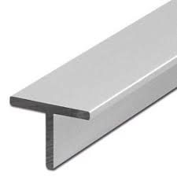

* T-section consists of a web and flange . It is designated by its overall width and depth.
* T-sections are available from 20mm x 20mm x 8mm to 150mm * 150mmx10mm with weight as 9N/m and 228N/m respectively.
* T-sections are widely used as members of steel roof trusses and to form built-up sections, chimney, steel bridges, etc
* **I SECTIONS**

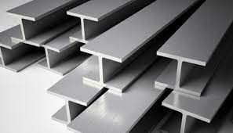

* I-sections are commonly known as rolled steel joists (R.S.J) or beams.
* An I section consists of 2 flanges and a connecting web.
* It is designated by overall depth, width of flange and weight per meter length.
* They are available in various sizes from 7Smm x 50mm at 61N/m to 600mm x 210mm at 995N/m.
* I-sections are suitable for beams, columns are available in 'H' sections which vary in sizes from 150mmx 150mm at 271N/m to 450mmx450mm at 925N/m.
* R.S.J. are economical in material and are suitable for beams, lintels, columns, grillage foundation, etc.
* Unequal I-sections with heavy weight are used as rails.
* **FLAT BARS**

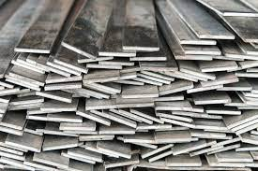

* These are available in suitable widths varying from 3 to 40mm.
* They are widely used for the construction of steel grill works, windows and gates
* **SQUARE BARS**

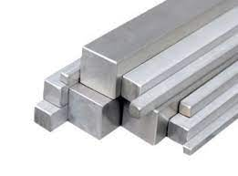

* These are bars with square cross-section.
* Size of square bars varies from 5mm square to 25 mm square and their corresponding weight per metre length are 2N and 48N.
* They are widely used in the construction of steel grill works, windows, gates, etc.
* **ROUND BARS**

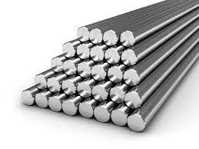

* These are bars with circular cross-section.
* They are available in diameters varying from 5 to 25mm and their corresponding weights per metre length of bars are 1.5 N and 38N.
* They are widely used as reinforcement in concrete of steel grill works, structures, construction etc.
* **EXPANDED METALS**

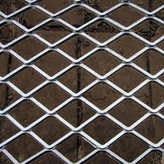

* Expanded metals are formed by cutting and expanding either plain sheets or ribbed sheets of steel.
* A diamond mesh appearance is formed throughout the area.
* The manufactured sheets are thus known as diamond mesh or rib mesh.
* The size varies from 30 to 150mm across the shorter length of the mesh and is available in length 1 to 3m and width 5m.
* Expanded metal is used as a reinforcement in ferro cement construction and for reinforcing foundation, road floors,bridges, etc.
* It is also used as lathing material
* **PLATES**

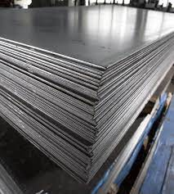

* Plate sections of steel are available in different sizes with thickness varying from 5 to 50mm and their corresponding weights are 392 N/mm sq and 3925 N/mm sq.
* Plates are used to connect steel beams for extension of length and for carrying tensional force in steel roof trusses.
* They are used to form built-up sections of steel.
* **CORRUGATED SHEETS**

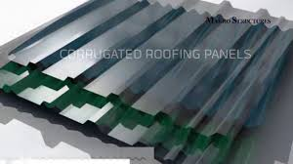

* These are formed by passing steel sheets through grooves.
* These grooves bend and press sheets, and corrugations are formed on the sheets.
* These corrugated sheets are galvanized and they are known as galvanized iron sheets or GI. sheets.
* These sheets are widely used as roof covering material.
* **PIPES, TUBES AND SHEETS**

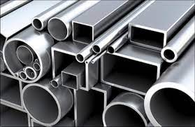

* Pipes are used for light columns and other structural purposes as well as its primary use as liquid conduits.
* Tubes of different shapes are available in market like round, square and rectangular
* It is used for framing roof truss and for light structural works, scaffolding, etc.
* Pipes over 15cm are sometimes casted as corrugated pipes, due to the difficulty of threading of pipe.
* **RIBBED TOR STEEL**

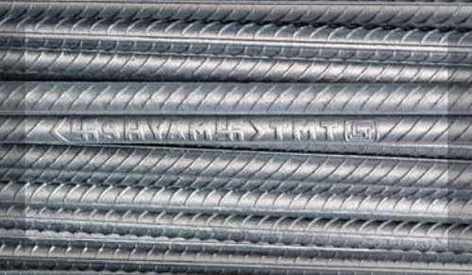

* The most commonly used steel for concrete reinforcement is TOR steel
* Other names : CTD bar,deformed steel bar, twisted steel bar, HYSD and CWD bar,
* It can be used for general concrete reinforcement in buildings, roads, bridges, sea walls, dams, etc.

### Steel Reinforcements

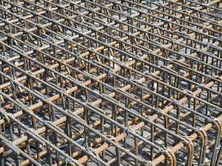

* Steel reinforcement are steel bars that are provided in combination with plain cement concrete to make it reinforced concrete.
* Hence these structures form steel reinforced cement concrete structures (R.C.C). Steel reinforcement is commonly called ‘rebars’.
* NEED FOR STEEL REINFORCEMENT
* Plain concrete is weak in tension and strong in compression. Tensile property for concrete structures is obtained by incorporating steel reinforcement.
* The steel reinforcement is strong in both tension and compression.
* The tensile property provided by the steel reinforcement will prevent and minimize concrete cracks under tension loads.
* The coefficient of thermal expansion of steel reinforcement and concrete are similar in that they undergo similar expansions during temperature changes.
* This property will ensure that the concrete is subjected to minimal stress during temperature variations.

### Types of steel

* **CARBON STEEL**



* Carbon steel looks dull, matte-like, and is known to be vulnerable to corrosion.
* Overall, there are three subtypes to this one: low, medium, and high carbon steel, with low containing about .30% of carbon, medium .60%, and high 1.5%.
* The name itself actually comes from the reality that they contain a very small amount of other alloying elements.
* They are exceptionally strong, which is why they are often used to make things like knives, high-tension wires, automotive parts, and other similar items.
* **ALLOY STEEL**

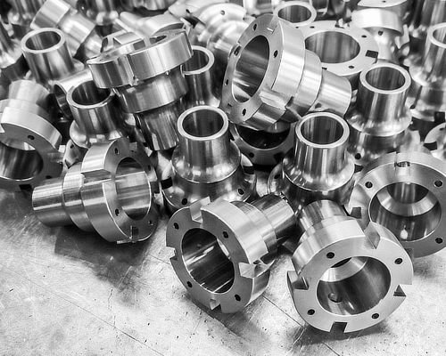

* It is a mixture of several different metals, like nickel, copper, and aluminum.
* These tend to be more on the cheaper side, more resistant to corrosion and are favored for some car parts, pipelines, ship hulls, and mechanical projects.
* For this one, the strength depends on the concentration of the elements that it contains.
* **STAINLESS STEEL**



* Stainless steels are probably the most well-known type on the market.
* This type is shiny and generally has around 10 to 20% chromium, which is their main alloying element.
* With this combination, it allows the steel to be resistant to corrosion and very easily molded into varying shapes.
* Because of their easy manipulation, flexibility, and quality, stainless steel can be found in surgical equipment, home applications, silverware, and even implemented as exterior cladding for commercial/industrial buildings.
* **TOOL STEEL**

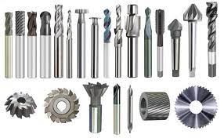

* Tool steel is famous for being hard and both heat and scrape resistant.
* The name is derived from the fact that they are very commonly used to make metal tools, like hammers.
* For these, they are made up of things like cobalt, molybdenum, and tungsten, and that is the underlying reason why tool steel has such advanced durability and heat resistance features.

### Uses of steel

* Soft and malleable steel is used for rolling into thin sheets
* Very soft and ductile steel is used for drawing into wires
* Very hard and brittle steel is used for making tools
* Steels are highly elastic, ductile, malleable, forgeable and weldable. They can be hardened and tempered and are fusible at a lower temperature than wrought iron. They retain magnetic properties as iron. Smithing of steel is more difficult than wrought iron. Steel is strong in compression and tension and hence it is suitable for all construction works
* Cast iron is granular and can take only compressive stress and hence its uses are limited to compression members. Wrought iron is fibrous in nature and suitable to resist tensile stresses.

### Properties of good steel

* Yield and tensile strength
* Fatigue stress
* Hardness
* Toughness
* Ductility
* Malleability
* Electrical conductivity
* Magnetic permeability
* Weldability
* Plasticity
* Light weight
* Corrosive resistance
* Abrasion resistance
* Wear resistance

MODERN CONSTRUCTION MATERIALS

# ARCHITECTURAL GLASS



* It is most typically used as transparent glazing material in the building envelope ( windows, external walls, etc ) and for internal partitions for giving a better appearance
* Glass is made by fusing oxides of silicon, boron or phosphorus with one of the basic oxides like soda, potash, lime and magnesia and a quantity of waste glass at or above 1000 degree celsius,followed by cooling the mixture rapidly to prevent crystallization
* Mechanical strength of ordinary glass varies from 350-700 kg/cm sq.
* Laminated glass is obtained by bonding 2 or more layers of glass together with an interlayer such as PVB, under heat and pressure to create a single sheet of glass whose interlayer provides much insulation.
* **PROPERTIES :**
* Transparent and translucent
* Absorb, reflect and transmit light
* Extremely brittle
* No definite crystalline structure
* Easily attacked by chemicals
* Take up high polish
* Available in different colors
* No sharp melting point
* Not affected by air or water
* **GLASSES AVAILABLE IN THE MARKET**
* SHEET :

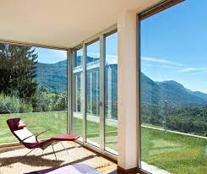

* made by blowing glass into a hollow cylinder, splitting the cylinder and then flattening it over the plane surface.
* Used in windows, glass doors, transparent screen, etc.
* PLATE :

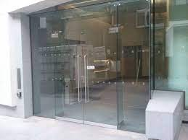

* Pouring white hot glass over iron table and rolling it to form uniform thickness using heavy roller
* Mirrors, large pane glass doors, window walls
* GROUND

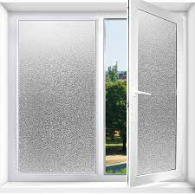

* Made by grinding one side or by melting powdered glass upon it to form translucent material
* Glazing doors, windows of bedrooms
* LAMINATED



* Made by binding two or more glass plates with intervening layers of transparent plastics by applying heat and pressure
* Automobile front glass, building doors and windows
* FLINT



* Made from a mixture of silica and lead and shines up and takes good polish
* Optical gass, electric bulbs
* INSULATING

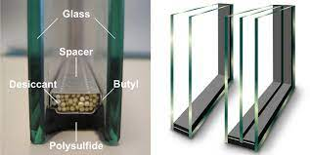

* Made by hermetically sealing two layers of glass separated by 6 mm to 12 mm of dehydrated air to provide heat insulation along with light transmission
* glazing doors and windows
* BULLETPROOF



* Alternate layers of plate glass and vinyl resin plastic
* Jewelry and automobile windows for safety from bullet attacks
* FIBER

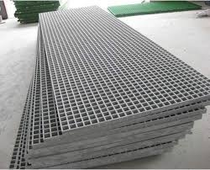

* Waterproof, acid proof and fireproof soft glass made by minute rods
* Thermal insulation sheets, reinforced plastics
* OPTICAL

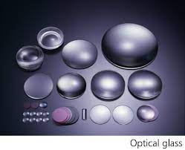

* Specially made glass considering the optical properties tomake it free from strains and effects, especially for laboratory purposes
* Lenses, prisms
* OPTICAL FIBER

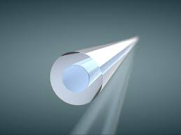

* Very fine strands of glass with a core of pure glass surrounded by different kinds of glass called the cladding for transmission of data using total internal reflection
* Telecommunication, endoscopy
* COLOURED



* Made by adding oxides of metal to molten glass
* Cosmetics,decorative doors and windows, drinking cups, bottles, jars, etc
* BLOCK

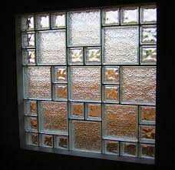

* Made by selling hollow blocks and fastening together with 2 halves of pressed glass
* Heat and sound insulation
* THERMOLUX

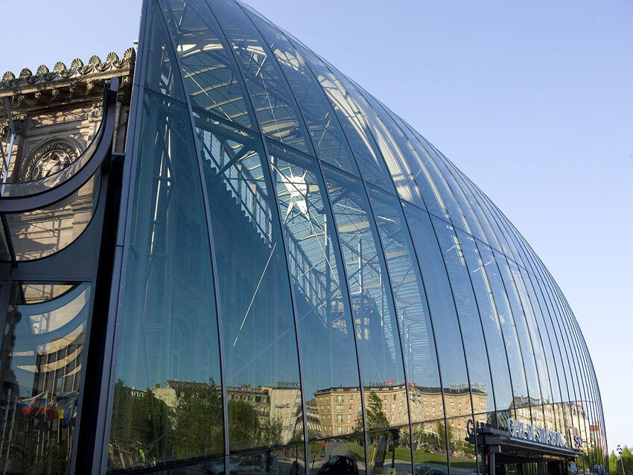

* Compound glass which consists of thin mat or or a layer of glass fiber between two sheets of ordinary glass which may be sheet, plate or other varieties.
* Used to provide a diffusing medium both for day or artificial lighting and also for thermal insulation
* WIRED

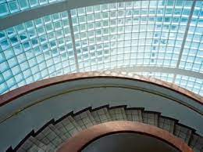

* Rough cast translucent glass made by embedding a wire mesh between layers of glass to offer higher fire resistance
* Fire resisting doors, roofs and windows

* PHOTOCHROMIC



* Obtained by adding silver iodide to increase sensitivity of glass to light and hence it darkens when exposed to sunlight and returns back to normal state in dim light
* Sun shield,sunglasses, etc.

# CERAMICS

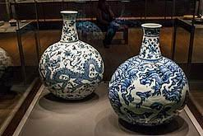

* A ceramic is any of the various hard, brittle, heat-resistant and corrosion-resistant materials made by shaping and then firing an inorganic, nonmetallic material, such as clay, at a high temperature.
* Common examples are earthenware, porcelain, and brick
* They are compounds between metallic and non-metallic elements for which the interatomic bonds are either ionic or predominantly ionic.
* **CLASSIFICATION :**
* **BASED ON COMPOSITION :** OXIDES, NITRIDES,SULFIDES, FLUORIDES, etc
* **BASED ON APPLICATION :**

#### GLASSES :



Non crystalline silicates that contain containing oxides of Ca,Na,K,Al,etc and used in containers, windows, mirrors,lenses,etc

#### CLAY PRODUCTS :

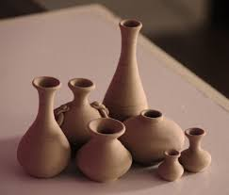

Used in bricks, tiles, terracotta, earthenware, stoneware and porcelain

#### REFRACTORIES

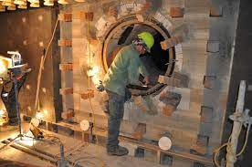

Ceramics encountered in modern manufacturing to withstand very high temperatures such as in furnaces, kilns,incinerators and reactors

#### ABRASIVES



An abrasive is a material, often a mineral, that is used to shape or finish a workpiece through rubbing which leads to part of the workpiece being worn away by friction.

Diamond,silica sand, silicon carbide, tungsten carbide etc

#### CEMENTS



Substances like Plaster of paris, lime, etc that when mixed with water form slurry which set and harden to obtain a desired shaped and also to establish bonding

#### ADVANCED CERAMICS

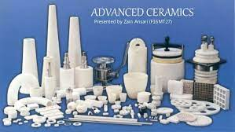

Advanced ceramics such as alumina, aluminum nitride, zirconia, silicon carbide, silicon nitride and titania-based materials, each with their own specific characteristics, offer a high-performance, economic alternative to conventional materials such as glass, metals and plastics.

# PLASTICS

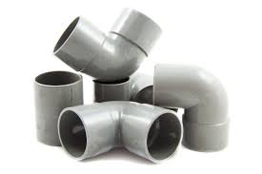

* Organic substances which consists of natural or synthetic resins with or without molding compounds
* Molding compounds are fillers, catalysts, hardeners, lubricants, pigments,plastisizers, solvent, etc
* **CLASSIFICATION**

#### **THERMOPLASTICS**

* plastics made up of polymer resins that becomes a soft material when it is heated and becomes hard when it is cooled
* These materials are easily recycled and do not show any chemical property changes when they are heated or cooled multiple times.

###### **VINYL**

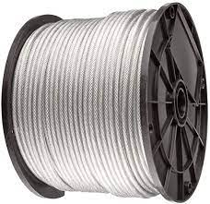

* Odorless, non-toxic, transparent and colorless
* Made by passing acetylene gas through acetic acid or hcl
* Cable, wire coatings

###### **STYRENE**

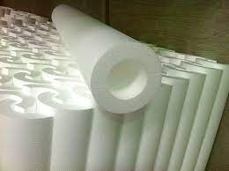

* Lightweight with high electric resistance
* Produced from ethylene from petroleum
* Insulators at radio frequency in wireless and television industry

###### **CELLULOSE**

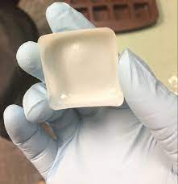

* Tough and strong with excellent electric properties
* Produced from cellulose acetate and esters
* Extruded films, eyeglass frames

###### **ACRYLIC**



* Excess optical properties and insulation
* Derived from coal, petroleum and water
* Safety glass, coloured and artificial jewels, lighting fittings

###### **ALKYD**

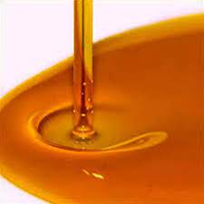

* Good electric properties
* Made from glycerol and phthalic anhydride
* Preparing thin films of plastic

###### 

#### **THERMOSETTING PLASTICS**

* synthetic materials that strengthen during being heated but cannot be successfully remolded or reheated after their initial heat-forming

###### **PHENOL FORMALDEHYDE**

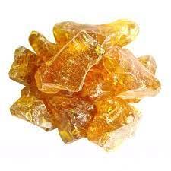

* High resistance to heat and excellent mechanical and electrical properties
* Made from phenol ( carbolic acid from coal tar) and formaldehyde ( hydrocarbon made from methane )
* Paints, varnishes, electrical fittings

###### **PHENOL FURFURALDEHYDE**

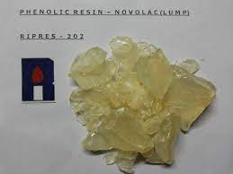

* Vapors are formed by digesting husks of rice, shells of ground nuts,etc with sulphuric acid in the presence of catalysts and the vapors are reacted with phenol to form the resin
* Dark in color and high temperature resistance
* Green adhesives novolac type

###### **UREA FORMALDEHYDE**

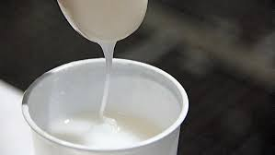

* Excellent electric properties
* Urea prepared by heating a mixture of liquid CO2 and liquid NH3 under pressure, is reacted with formaldehyde to form the resin
* Adhesives for wooden products, lighting fixtures

###### **CASEIN**



* Bright attractive appearance good workability
* Phosphor protein derived by precipitation of milk with acids
* Buckles, buttons
* **ADVANTAGES**
* Waterproof, rustproof, rot proof, termite proof
* Cheap
* Good electrical and optical property
* Available in various colors
* Clean, light and shining
* Can be drilled, punched and sawed
* Good thermal insulation
* Does not require painting and polishing

# COMPOSITE MATERIALS

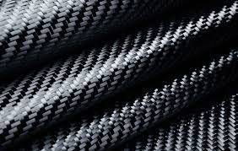

* A composite material is a material which is produced from two or more constituent materials.
* These constituent materials have notably dissimilar chemical or physical properties and are merged to create a material with properties unlike the individual elements.
* The four pri- mary categories of composites are polymer matrix composites (PMCs), metal matrix compos- ites (MMCs), ceramic matrix composites (CMCs), and carbon matrix composites (CAMCs).
* There are five basic types of composite materials:
  + **Fiber,**
  + **Particle,**
  + **Flake,**
  + **laminar or layered and**
  + **filled composites**.
* Currently, the most common fibers used in composites are glass, graphite (carbon), boron and Kevlar

# THERMAL AND ACOUSTIC INSULATING MATERIALS

* + Thermal insulation restricts heat transfer, whereas acoustic insulation restricts sound transfer or sound reverberation. The combined product is thermal acoustic insulation, which is effective in both reducing heat and noise transfer

# DECORATIVE PANELS

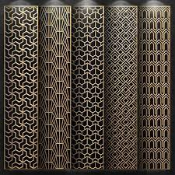

* decorative treatment of walls, ceilings, doors, and furniture consisting of a series of wide, thin sheets of wood, called panels, framed together by narrower, thicker strips of wood.
* **TYPES OF DECORATIVE PANELS**
  + Board and Batten panels.
  + Shiplap panels.
  + Plank wall panels.
  + Beadboard panels.
  + Tongue and groove panels.
  + PVC wall panels.
  + Peel & Stick reclaimed wood planking.
  + Flat Wall Panels.
* Wainscoting is a broader term referring to decorative paneling used for centuries
* **USES OF DECORATIVE PANELS**
  + Easy installation
  + Enhanced aesthetics
  + Can conceal uneven wall surfaces
  + Hides electric cables
  + Reusable

# WATERPROOFING MATERIALS

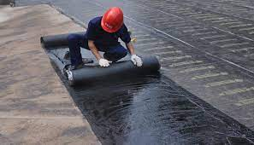

* Waterproofing is the process of making an object or structure waterproof or water resistant.
* the insulated material or structure remains unaffected by water or resists water ingress under the specified conditions
* Such articles may be used in wet environments or under specified depths.
* **TYPES OF WATERPROOFING MATERIALS**
* Cementitious Waterproofing.
* Liquid Waterproofing Membrane.
* Bituminous Coating Waterproofing.
* Bituminous Membrane Waterproofing.
* Polyurethane Liquid Membrane Waterproofing
* **WATERPROOFING COMPONENTS**
* Cementitious coating
* EPDM rubber
* Bitumen
* Roofing felt
* Mastic Asphalt
* Thermoplastic
* Sheet waterproofing membrane
* PVC waterproofing membrane

# MODERN USES OF GYPSUM

# 

* Rock-like minerals found in the earth's crust, extracted, processed and used by man in construction/decoration in the form of paste/alabaster.
* Chemical composition : Calcium sulfate dihydrate CaSO4.2H2O with impurities like MgO, Al2O3, Fe2O3, SiO2,CaCO3, MgCO3 which add color to gypsum
* A richness of forms can be created in an affordable budget and can be installed easily
* Gypsum products can to disintegrate when exposed to moisture and therefore should not be used for exterior work and for moist interiors
* Gypsum often serves as a fireproofing material and thus acts as an acoustic insulating material, besides its uses in ornamental works of architecture.
* **MODERN USES**
* **GYPSUM BOARD/DRYWALL/ PLASTERBOARDS**

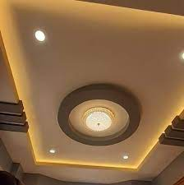

* Gypsum board/ drywall is the technical product name used by manufacturers for a specific board with a gypsum core and a paper facing
* Gypsum board is a premier building material for wall ceiling and partition systems in residential institutional and commercial structures and is designed to provide a monolithic surface when joints and fastened heads are covered with a joint treatment system
* **PLASTER OF PARIS**



* Quick setting gypsum plaster consisting of a fine white powder which hardens when I stand and allowed to dry is called plaster of Paris
* Master of Paris is used in architecture for sculpturing and ornamental work, making casts and patterns, in hospitals for immobilizing the affected part in case of bone fracture, making fireproofing materials and also for making chalks
* **HARD WALL PLASTER**

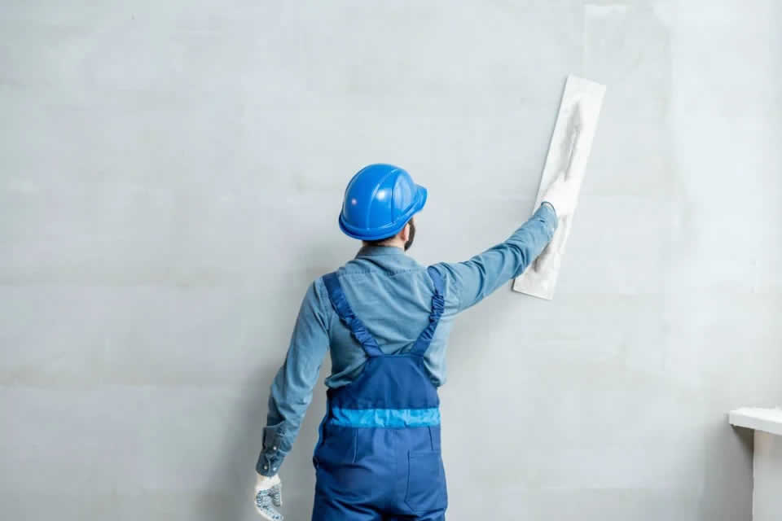

* Hard wall plaster is an undercoat plaster that is most commonly used with masonry background like bricks and medium density blocks
* It is used for plastering walls production of prefabricated structural units and masonry bricks and blocks
* **FLOORING HARD FINISH PLASTER**

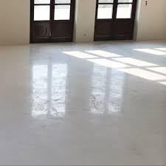

* Hard finish plaster is a multipurpose product that is designed to produce a robust, smooth and abrasion resistant finish over masonry brick or concrete services
* Used in flooring and pavement of bricks and tiles

# PREFABRICATED BUILDING COMPONENTS

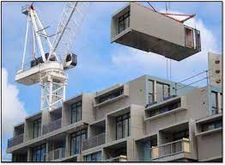

* Prefabrication is the practice of assembly components of a structure in a factory for other manufacturing side and transporting complete assemblies for sub assemblies to the construction site where the structure is to be located
* Such components are called prefabricated building components or prefabricated units and include doors, stairs, windows, wall panels, floor panels,Good roof trusses and room size components
* There are several materials used in prefabrication buildings, including concrete, steel,aluminum, ceramics and wood.
* 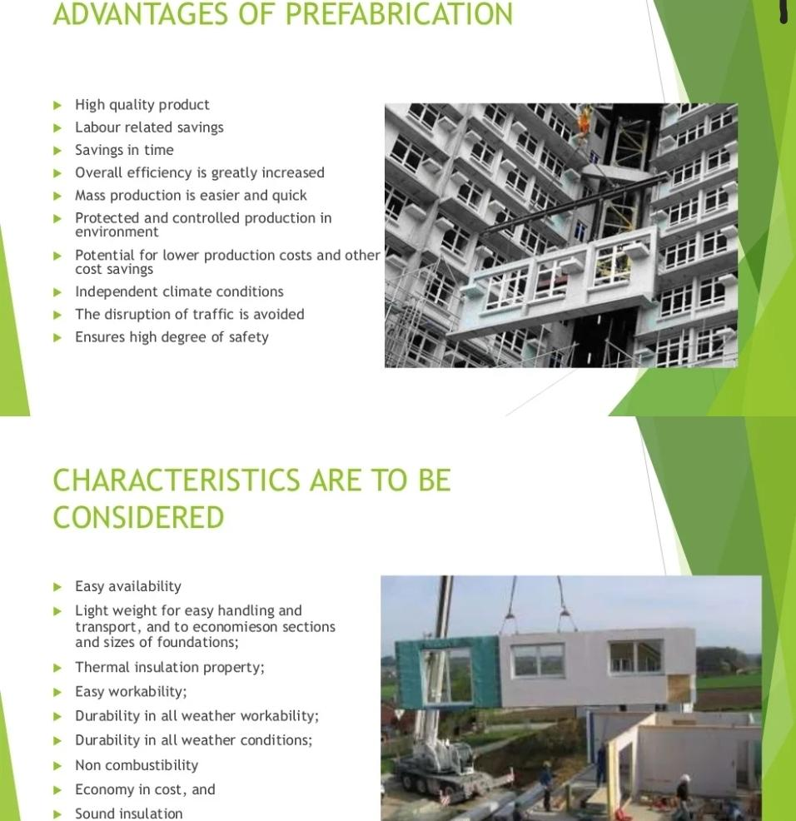
* **TYPES OF PREFAB SYSTEMS**
* 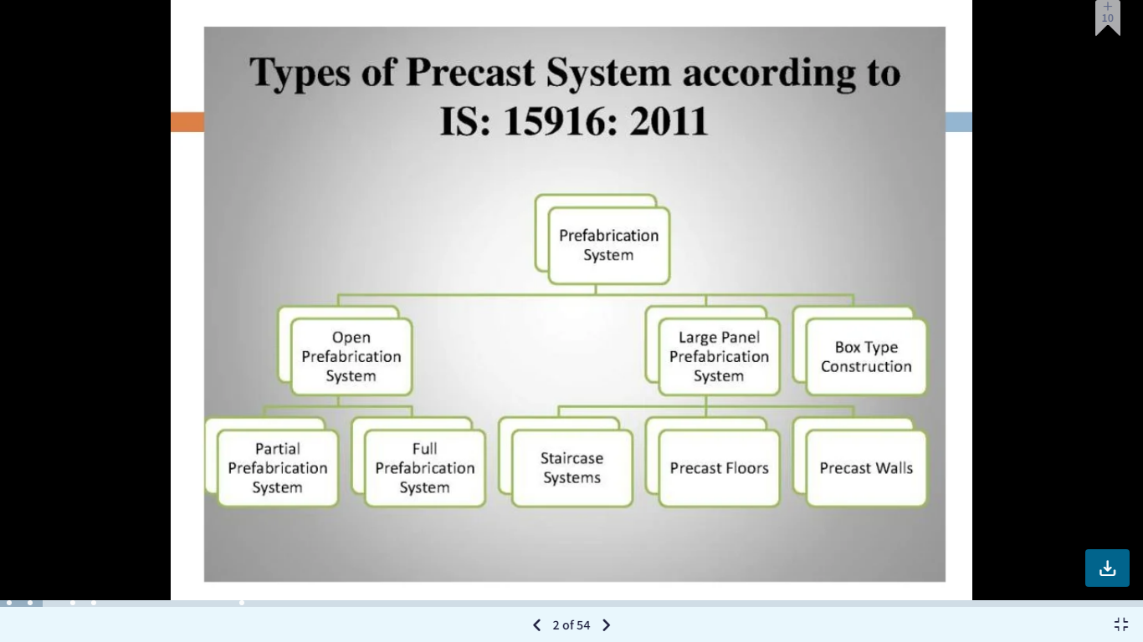
* **OPEN PREFAB SYSTEM**
* Open prefab system is based on the use of basic structural elements from whole or part of a building
  + 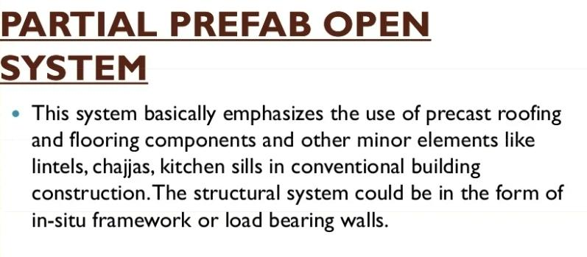
  + 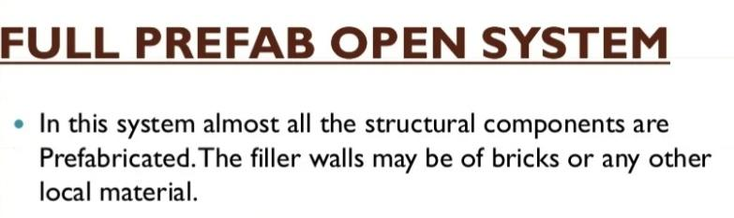
* **LARGE PANEL PREFAB SYSTEM**
* 
* Large panel prefab system is based on the use of large prefab components as in large panels for walls floors rules balcony staircase casting should be done on site or off site
* **TYPES OF LARGE PANEL SYSTEMS:**
  + **WALL SYSTEMS**
    - 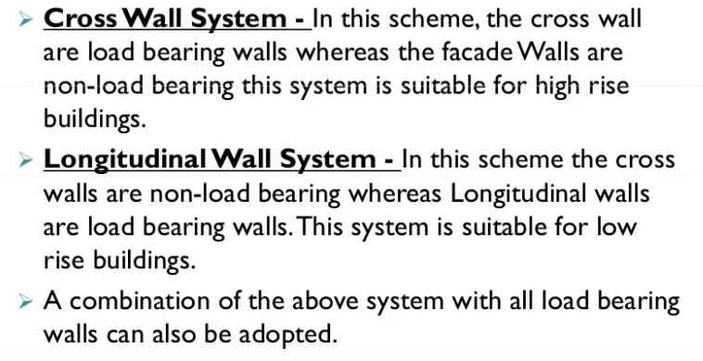
  + **PRECAST WALLS**
    - 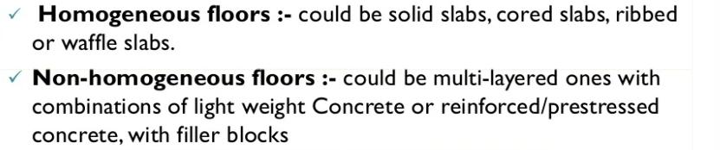
  + **STAIRCASE SYSTEMS**
    - 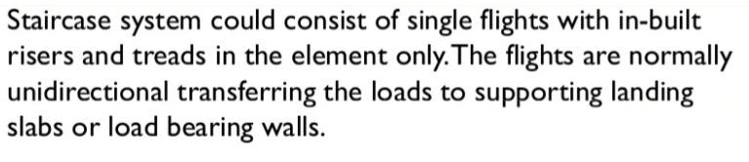

**BOX TYPE CONSTRUCTION**

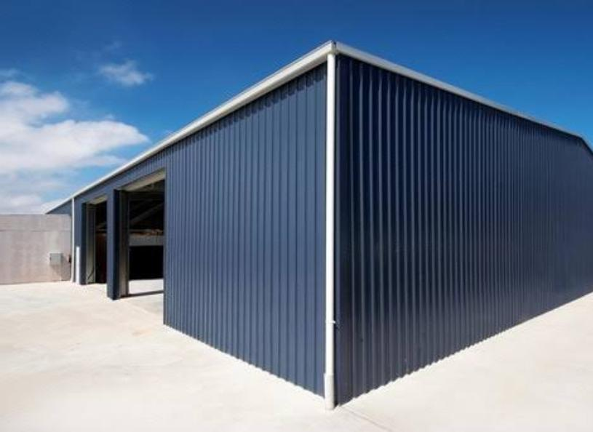

* + - In this system, room size units are prefabricated and erected at site.
    - Toilets and kitchen blocks also be similarly prefabricated and erected at site
    - This system derives its stability and stiffness from the boxunit which are formed by the four adjacent walls which are jointed to make rigid connections among among themselves
    - The box unit rests on the plinth foundation which may be of conventional type or precast type